PROJECT DOCUMENTATION

**Grievance Redressal**

**System**

INTRODUCTION

### **PROJECT DESCRIPTION**

The Public Grievance Redressal System is a web based application. The application is developed mainly for the use of customers for submitting their grievance to various sectors of their products.

The project is based on three users: Admin, Customer and Customer Service Representative (CSR). Customer is mainly focused on submitting their grievance. Admin can assign the CSRs to the departments, to which, Customer can submit their complaint. The CSR of each department will first approve the complaint and assign the grievances to the concerned department. The Customers nowadays face a lot of problem to give their complaints to the company. They have to directly meet the higher authorities, which takes lots of time. By using this system, instead of going directly, people can submit their grievance online and get resolutions in a streamlined manner.

The complaint that is registered by the Customer will be received by the respective departments. The particular employee of that department will resolve the problem.

This project has three modules: Admin, Customer and CSR. Admin can login to the system with username and password. He can view all the Customer profiles registered. The admin has the rights to add the CSRs of each department to which grievances can be send. Admin can view whole report of total grievances received and those that are solved. First of all, Customer has to login into the system using username and password to submit the complaint. For the first time when Customer login the password has to be changed. They have the option to update their profile. Customers can select the particular department for which they have complaint and then register their grievance by filling the form. They can also check the status of the complaint. The department head can login to the system and view the grievance that has been received.

### **TOOLS AND TECHNOLOGY USED**

#### **Java**

Java language is used as front end tool for developing this project. Java is platform independent, so that any java application can be run on any operating system. There are many features for java. Java programs are portable in network, Java codes are robust. Java is an object oriented language. Java should be installed in the device to run any java application or website. The java software contains the Java Runtime Environment (JRE) that is needed to run in a web browser.

#### **JSP**

JSP stands for **Java Server Pages**. It is a server side technology used for creating web application. It is used to create dynamic web content.

In this JSP tags are used to insert JAVA code into HTML pages.

It is an advanced version of Servlet Technology.

It is a Web based technology helps us to create dynamic and platform independent web pages. in this, Java code can be inserted in HTML/ XML pages or both. JSP is first converted into servlet by JSP container before processing the client’s request.

#### **MySQL**

MySQL is the database management system used in this system. It is a famous open-source Relational Database Management System(RDBMS). MySQL was first owned by a Swedish company called MySQL LAB, but it is now owned by Oracle Corporation. The SQL part of MySQL stands for “Structured Query Language. SQL is the commonly used language to access database.

#### **Struts2 Framework**

Apache Struts 2 is an elegant, extensible framework for creating enterprise-ready Java web applications. This framework is designed to streamline the full development cycle from building, to deploying and maintaining applications over time. Apache Struts 2 was originally known as Web Work 2. This tutorial will teach you, how to use Apache Struts for creating enterprise-ready Java web applications in simple and easy steps.

#### 

### **HARDWARE AND SOFTWARE REQUIREMENTS**

#### **Software Requirements**

Operating System: Windows 7 or above

Front End :  JS/HTML

Backend : Java

Database : MySQL

#### **Hardware Requirements**

Processor : Pentium (IV) or higher

Primary Memory  : 1 GB or higher

Network    : Internet Connectivity

### **USERS**

“Public Grievance Redressal System” is focusing on three users: Admin, Customers and CSR. Admin has the responsibility to add various departments to the system. Customers can register their grievance to the site. Then the CSR will assign the Grievance to the concerned Department and a Technician will be assigned.

**Admin:**The admin part handles the administration part of the whole system. The admin can handle the overall responsibility of the system. The admin user should be able to:

* Add Departments: Admin can add Departments for the various departments of the system to which the Customers can register their complaint.
* View Users: Admin can view the details of all the users who are registered in the system.
* View Complaints: Admin can view all the grievances registered by the public Customers.
* Generate report: Admin can view report of complaints that are registered and solved.

**Customer:**The User module handles the activities of the Customers registered in the system. The Customer is able to login to the system by specifying the username and password. After login, Customer registers complaint to a particular department and checks the status. The Customer should able to:

* View and update profile: Customers can view their profile and make updates if needed.
* Register complaint: Customers can register their complaints to a particular department.
* Check complaint status: Customers are able to view their complaint status to know the action taken.
* Reopen complaint: Customers can reopen their complaint which has been closed by the department head after solved.
* Send feedback: Customers can send feedback to different departments.

**Customer Service Representative:**The CSR of each department can login to the system using username and password. They can view the complaints that are registered to their department and approve the complaints. The department head can change the status of the complaint to modify the progress of complaint. This user should able to:

* View grievance: The department CSR can view all the complaints received by their department.
* Approve complaint: CSR has to view and approve the complaint before processing on it.
* Change status: The CSR can change the status of each complaint based on the action taken.
* Close complaint: The CSR can close any complaints that have been solved.
* View feedback: The Department head can view the feedback sent by the Customers.

### **3.3 Database Specifications**

Functional Requirements of “Public Grievance Redressal System” are:

1. Registration:

Registration module is used for registering the Customer account into the system.

* **Input:** username, password, name, address, email, phone.
* **Output:** User is registered to system.
* **Processing:** All fields are entered as per the constraints

1. Login:

Login is used so that the authorized person can enter into the system. Only registered users can login.

* **Input:** username, password.
* **Output:** User is logged in and authorized page is displayed.
* **Processing:** Login is not allowed if wrong username and password is entered.

1. Complaint:

This is used by the users to register their grievances through this website.

* **Input:** Subject, description
* **Output:** Complaint is registered.
* **Processing:** Complaint is saved in the particular department.

1. Status:

This is used by the user to check the status of their registered complaint.

* **Input:** Complaint id
* **Output:** Status is displayed.
* **Processing:** Valid complaint id should be entered to view status.

1. Reports

It is used for generating various reports by the admin.

* **Input:** start date, end date, CSR id
* **Output:** Report is generated

**System flow**

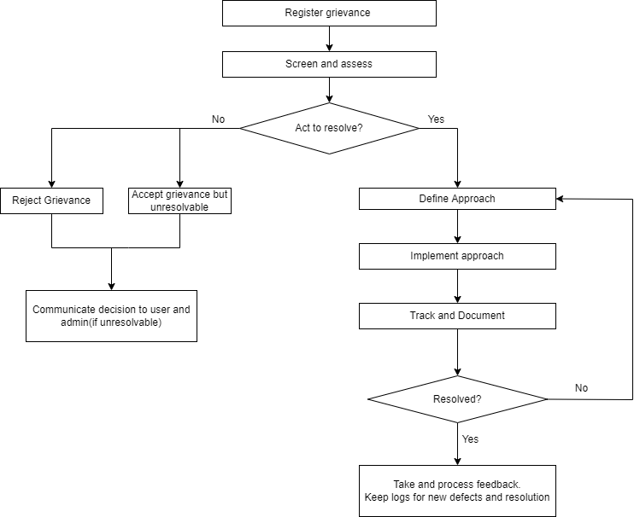

Database Structure

|  |  |
| --- | --- |
| UserInfo | |
|  |  |
| pid(PK) | INT |
| username | VARCHAR(25) |
| password | VARCHAR(25) |
| Name | VARCHAR(45) |
| Address | VARCHAR(100) |
| email | VARCHAR(25) |
| phno | INT |
| tid(FK) | INT |
| userstatus | BOOLEAN |

|  |  |
| --- | --- |
| UserType | |
|  |  |
| tid(PK) | INT |
| role | VARCHAR(25) |

|  |  |
| --- | --- |
| Product Owned | |
|  |  |
| oid(PK) | INT |
| pid(FK) | INT |
| prodid(FK) | INT |

|  |  |
| --- | --- |
| Product | |
|  |  |
| prodid(PK) | INT |
| did(FK) | INT |
| prodmodel | VARCHAR(10) |
| prodname | VARCHAR(50) |

|  |  |
| --- | --- |
| Dept |  |
|  |  |
| did(PK) | INT |
| dname | VARCHAR(25) |

|  |  |
| --- | --- |
| Complaints | |
|  |  |
| cid(PK) | INT |
| ctime | DATETIME |
| subject | VARCHAR(45) |
| description | VARCHAR(200) |
| pid(FK) | INT |
| tid(FK) | INT |
| status | BOOLEAN |
| proid(FK) | INT |

|  |  |
| --- | --- |
| Technician | |
|  |  |
| tid(PK) | INT |
| tname | VARCHAR(45) |
| did(FK) | INT |

|  |  |
| --- | --- |
| Feedback | |
|  |  |
| fid(PK) | INT |
| cid(FK) | INT |
| feedback | VARCHAR(200) |
| rating | INT |

|  |  |
| --- | --- |
| Progress | |
|  |  |
| proid(PK) | INT |
| startprog | VARCHAR(200) |
| ongoingprog | VARCHAR(200) |
| endprog | VARCHAR(200) |
| resolved | BOOLEAN |